**WEB DESIGN.**

**INSTRUCTIONS FOR ACTIVITIES:**

**2 Web page design**

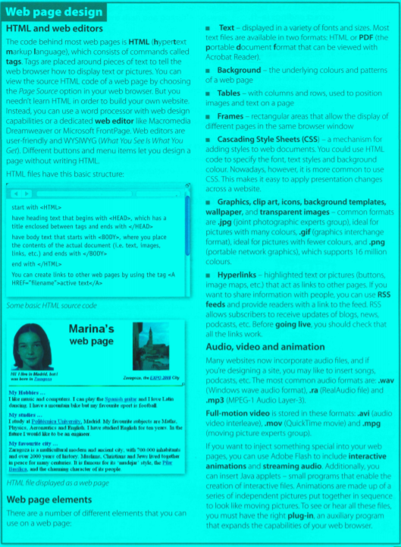

**Page 114, ex. 2A Read the text on page 115 and find the following**

1 the language used to create web documents

HTML

2 the type of software that lets you design web pages without writing HTML codes

Web editor

3 the format invented by Adobe to distribute text files over the internet

Pdf

4 a method of displaying multiple HTML documents in the same browser window

frames

5 three common graphics formats used on websites

.jpg

6 three popular formats used to store and play back video

.avi

**Page 116, ex. 2B Read the text again and then match the sentence beginnings correct endings (a-f).**

**1** Instructions in HTML

**c** are called tags

**2** Cascading Style Sheets are the way

**e** to define the presentation of web pages, from fonts and colours to page layout

**3** A hyperlink is any clickable text,

**a** image or button that takes you to another place on the Web

**4** A plug-in is a small program

**b** used for handling audio, video and animation files

**5** Java applets are used to provide

**d** interactive features to web applications

**6** RSS feeds are summaries of web content

**f** published in the Really Simple Syndication format for download

**Page 117, ex. 3B Complete these sentences with suitable modal verbs from the HELP box. There may be more than one possible answer.**

**HELP box**

**Modal verbs**

We use modal verbs to add extra meaning to the main verb. They are followed by infinitive design web pages without to Modal verbs are used in the following ways :

* To express a possibility

You **can/could** use Adobe Flash to include interactive animations.

You **may** like to insert songs, podcasts, etc.

The price of Dreamweaver **might** go down next month.

**Can** and **could** are often interchangeable when talking about possibility. **May** and **might** are used to express weaker possibilities an often come before the verb **like** to

mean It is possible you will like.

* To ask for permission

**Can/could / May** I use your mobile phone?

**May** is more formal than **can** or **could**

* To talk about ability

They are looking for artists who **can** draw and design web pages.

**Could** is the past tense of can and is used to talk about ability in the past

* To talk about obligation or necessity

To see or hear all these files, you **must** have the right plug-in.

….you needn't learn HTML in order to build your own website

**Needn't** means don't need to or don't have to and is used to express a lack of obligation.

* To give advice (see Unit 7)

Before going live, you **should** check links work

**1** With Java I can/could include some attractive banners on my website.

**2** With a web editor you can/could create a web document easily.

**3** These days, you learn needn’t how to use complicated HTML codes. Modern web design software is user-friendly and converts a visual layout into HTML code.

**4** Once live you should update your website regularly.

**5** To view a PDF file you must have Adobe Acrobat Reader.

**6** Websites with graphics are more inviting than those may/might written in plain text, so you like to insert some graphics into your documents

**7** Can/Could/May use your laptop? I Need to print out this report.

**Page 117, ex. 4B Listen to an interview with a web designer describing how to design a website and put these steps into the correct order**.

2 Write and format the text

1 Decide the content and structure for the website

5 Publish the website

3 Insert computer graphics and sounds

6 Keep the website updated

4 Link related pages to each other using hyperlinks

**Page 118, ex. 4C Listen again and decide whether these design guidelines are right wrong. Tick the correct box.**

**1** Plan your website carefully. --------------------------------------------------------->Right

**2** Use a web editor. It will make it easier to create your pages --------------->Right

**3** Insert photos or animations just to make the pages look attractive-------->Wrong

**4** Place a large number of graphics on your pages ------------------------------>Wrong

**5** Use very bright colours. --------------------------------------------------------------->Wrong

**6** Put a lot of links on one page--------------------------------------------------------->Wrong

**7** Check that all the links on your web pages are correct.------------------------>Right

**8** Once they are published, update your pages regularly------------------------->Right

**Page 118, ex. 5D** **Write an entry for the blog you've described in C (80-100 words). Introduce the blog to the world and talk about why you've started it.**

Now visit www.cambridge.org/elt/ict for an online task.

I would create a blog that would be related to new technologies.

Where interested people would have all the information that I'm collecting. Of interesting web pages and help.

He would have a forum where he would discuss the doubts that he could solve and also to talk about the new technologies.

Everything would be well specified and in order to facilitate reading.

I would also have a section for videos and podcasts. Where would talk about the news in mobile telephony and upload videos of reviews of the latest models of the market, repairs, etc.